MODUL 4

Nama : Edi Supriyanto Kelas : A

NIM : L200180002

* Percobaan 1

1. 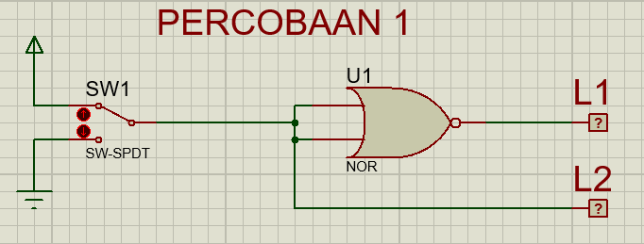

2. Fungsi Boolean : **L1 = L2 + L2 = L2**

3. Tabel Kebenaran

|  |  |  |
| --- | --- | --- |
| SW 1 | L2 | L1 |
| 0 | 0 | 1 |
| 1 | 1 | 0 |

4. Diagram waktu

|  |  |  |
| --- | --- | --- |
| L2 |  |  |
|  |  |
|  |  |  |
| L1 |  |  |
|  |  |

5. Kesimpulan :

Gerbang NOR pada Gambar 4.3 membentuk logika dari gerbang NOT

* Percobaan 2

1. 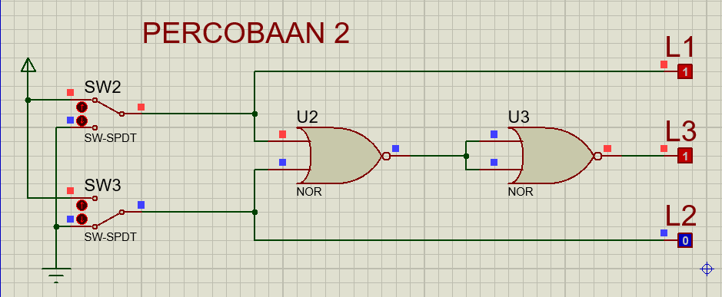

2. Fungsi Boolean : **L3 = L1 + L2 = L1 + L2**

3. Tabel Kebenaran

|  |  |  |  |  |
| --- | --- | --- | --- | --- |
| SW 1 | SW 2 | L1 | L2 | L3 |
| 0 | 0 | 0 | 0 | 0 |
| 1 | 0 | 1 | 0 | 1 |
| 0 | 1 | 0 | 1 | 1 |
| 0 | 1 | 1 | 1 | 1 |

4. Diagram waktu

|  |  |  |  |  |
| --- | --- | --- | --- | --- |
| L1 |  |  |  |  |
|  |  |  |  |
|  |  |  |  |  |
| L2 |  |  |  |  |
|  |  |  |  |
|  |  |  |  |  |
| L3 |  |  |  |  |
|  |  |  |  |

5. Kesimpulan :

Gerbang NOR pada Gambar 4.4 membentuk logika dari gerbang OR

* Percobaan 3

1. 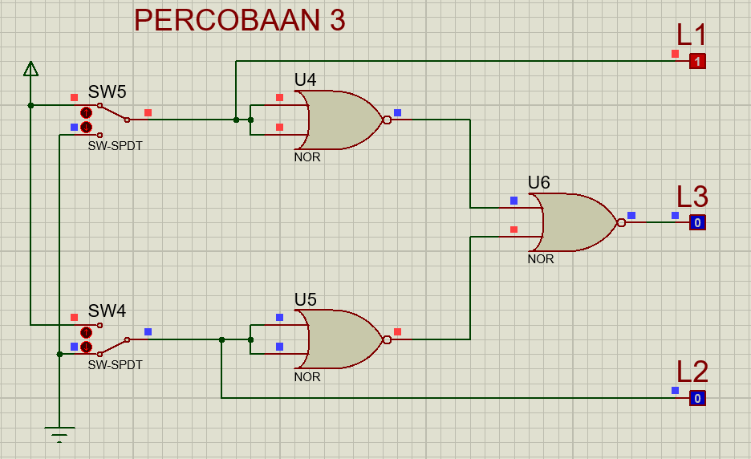

2. Fungsi Boolean : **L3 = L1 + L2 = L1 . L2**

3. Tabel Kebenaran

|  |  |  |  |  |
| --- | --- | --- | --- | --- |
| SW 1 | SW 2 | L1 | L2 | L3 |
| 0 | 0 | 0 | 0 | 0 |
| 1 | 0 | 1 | 0 | 0 |
| 0 | 1 | 0 | 1 | 0 |
| 0 | 1 | 1 | 1 | 1 |

4. Diagram waktu

|  |  |  |  |  |
| --- | --- | --- | --- | --- |
| L1 |  |  |  |  |
|  |  |  |  |
|  |  |  |  |  |
| L2 |  |  |  |  |
|  |  |  |  |
|  |  |  |  |  |
| L3 |  |  |  |  |
|  |  |  |  |

5. Kesimpulan :

Gerbang NOR pada Gambar 4.5 membentuk logika dari gerbang AND

* Percobaan 4

1. 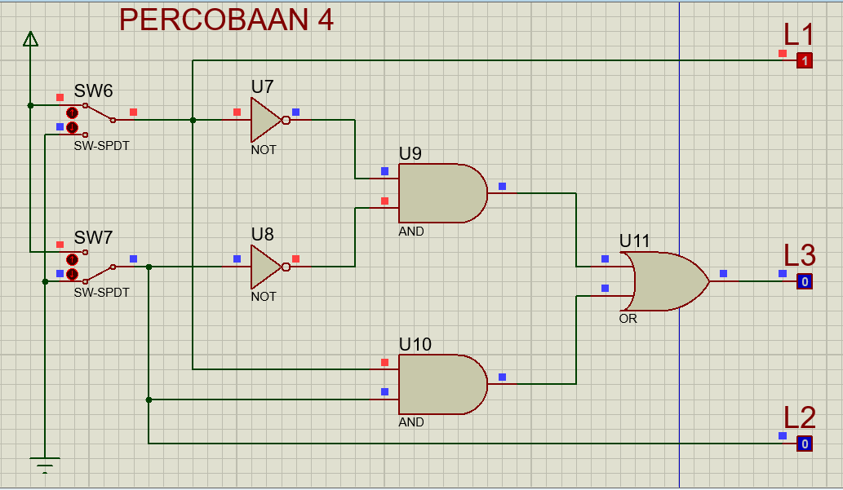

2. Fungsi Boolean : **L3 = L1 + L2 + L1 L2 = L1** ⨁ **L2**

3. Tabel Kebenaran

|  |  |  |  |  |
| --- | --- | --- | --- | --- |
| SW 1 | SW 2 | L1 | L2 | L3 |
| 0 | 0 | 0 | 0 | 1 |
| 1 | 0 | 1 | 0 | 0 |
| 0 | 1 | 0 | 1 | 0 |
| 0 | 1 | 1 | 1 | 1 |

4. Diagram waktu

|  |  |  |  |  |
| --- | --- | --- | --- | --- |
| L1 |  |  |  |  |
|  |  |  |  |
|  |  |  |  |  |
| L2 |  |  |  |  |
|  |  |  |  |
|  |  |  |  |  |
| L3 |  |  |  |  |
|  |  |  |  |

5. Kesimpulan :

Gerbang NOR pada Gambar 4.6 membentuk logika dari gerbang XNOR

* Percobaan 5

1. 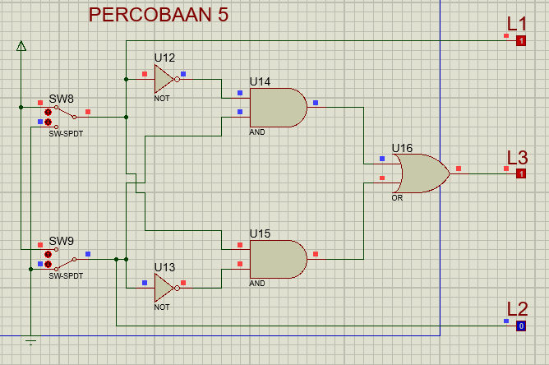

2. Fungsi Boolean : **L3 = L1 L2 + L1 L2**

3. Tabel Kebenaran

|  |  |  |  |  |
| --- | --- | --- | --- | --- |
| SW 1 | SW 2 | L1 | L2 | L3 |
| 0 | 0 | 0 | 0 | 0 |
| 1 | 0 | 1 | 0 | 1 |
| 0 | 1 | 0 | 1 | 1 |
| 0 | 1 | 1 | 1 | 0 |

4. Diagram waktu

|  |  |  |  |  |
| --- | --- | --- | --- | --- |
| L1 |  |  |  |  |
|  |  |  |  |
|  |  |  |  |  |
| L2 |  |  |  |  |
|  |  |  |  |
|  |  |  |  |  |
| L3 |  |  |  |  |
|  |  |  |  |

5. Kesimpulan :

Kombinasi Gerbang akan membentuk logika dari gerbang XOR